What is HQMS ?
HQMS is a web based quality management system that will be used by Watts to improve our communication and product quality with our suppliers and customers. The goal of HQMS is to provide better tracking of issues with our suppliers, effective solutions and timely closure. Below is an example of an 8D that will be accessible through our HQMS program. Other documents will also soon be used through our HQMS program such as the Production Part Approval Process (PPAP).

What is an 8D?
- The 8D is an 8 step Discipline method used to approach and to resolve problems. Its purpose is to identify, correct and eliminate recurring problems and it is useful in product and process improvement. It establishes a permanent corrective action based on statistical analysis of the problem (when appropriate) and focuses on the origin of the problem by determining its root causes. The 8D form.docx is a visual example of what the supplier will see when they are issued an 8D via email through the Watts HQMS system.
- The 8D Discipline Approach.docx has been provided as an aid for the supplier to help them understand how to approach each process step so it can be completed. Please Note: only Steps D3 thru D8 are accessible for the adding of text by the supplier into the 8D form at this time.

Compatibility View Settings for Suppliers to view an 8D via email.
- Suppliers may need to update their Internet Explorer (IE) settings under Compatibility view settings to enable the saving of their responses into the 8D form by adding hgihost.com to their Compatibility view setting under IE and saving it. (see attachment for instructions)

8D Email Hyperlink Example
- When a requested 8D is initiated by Watts an email will be sent with several automated Hyperlinks that will be generated in the email. Only the “Comport” hyperlink will give you access to the 8D via the HQMS software that has been issued to a Supplier. See Example Below:
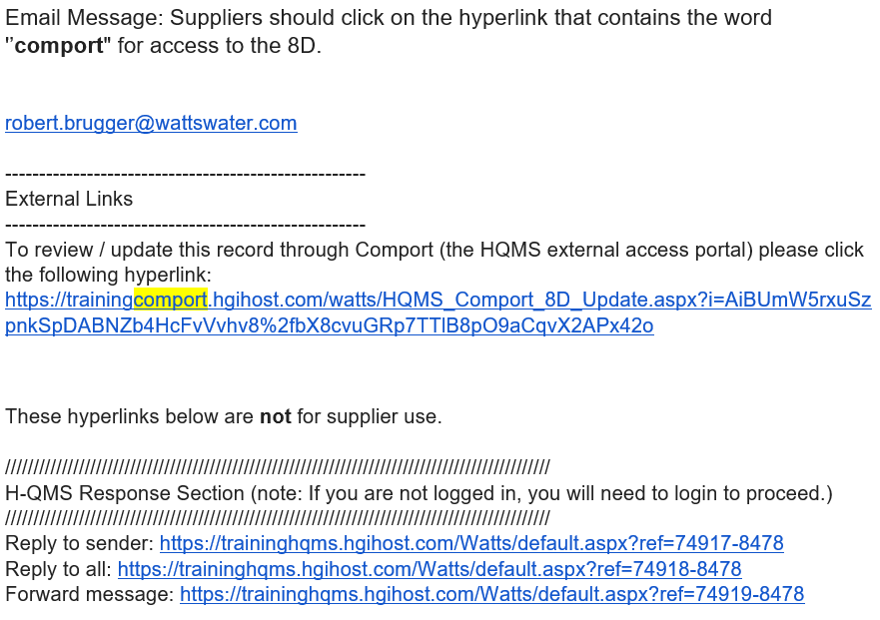
- Important: Suppliers are requested to acknowledge receipt of the email for the requested 8D or Corrective Action back to the person who issued the 8D or Corrective Action. A simple email acknowledgement is all that is required.

- Note: Please ensure that Microsoft Outlook is in HTML mode otherwise the HTML link may be broken and will not function properly when selected or sent to another email contact.
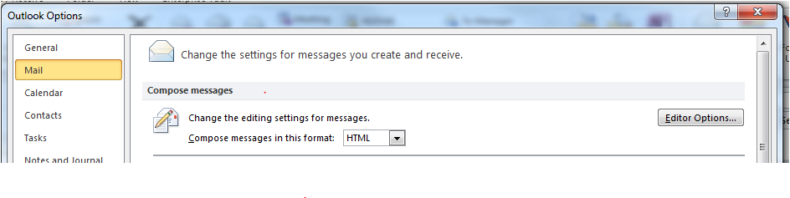
INFORMATIONAL NOTES FOR OUR SUPPLIERS for an 8D
IMPORTANT: When adding your response for each of the sections, D3-D8 (save each section you complete) as noted in step F to avoid any loss of your input.
- When updating the 8D form if a supplier enters incorrect information (Example: 100% as oppose to 100) and then tries to save the form, it will not save the data and the form will scroll to the top to show you the error in red. See Example below.
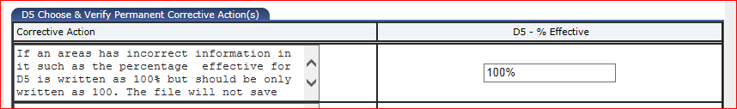

- When updates are made to the 8D form in each section by the Supplier they can be saved by Scrolling down to the bottom of the page and clicking on the floppy disk save icon. This will save the added data to HQMS for Watts to review.
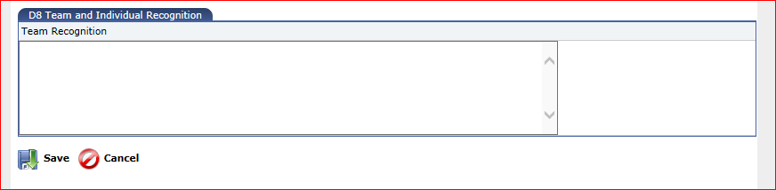
- A correctly saved page will show the information below. The supplier can also review
the updates made by clicking on the wording Reload Page as seen below. Additional updates or corrections can also be made once the page has been reloaded and then must be saved again by clicking on the floppy disk icon as seen just above.
